The Periodic Table of Human Interaction

1. The Terms
A. Primary Needs (The Gravity)
- Safety: Physical security or psychological "face" saving.
- Autonomy: The need for choice; avoiding being "done to."
- Competence: The need to feel capable/effective.
- Significance: To be seen, to have status, to matter.
- Order: To reduce entropy; predictability.
- Belonging: Acceptance without performance.
- Meaning: Purpose, justice, or "righting the scales."
B. Worldviews (The Filter)
- Survival: The world is a threat (High Cortisol).
- Deficiency: The world is a desert (Scarcity).
- Identity: The world is a ladder/courtroom (Status).
- Operational: The world is a machine (Logistics).
- Unity: The world is a shared garden (Flow).
- Ludenic: The world is a playground (Play).
- Sacred: The world is a temple (Awe/Birth/Grief).
C. The Gambits (The "Throw")
- The Structuralists
  - Tool: Providing raw data, logistics, or immediate "how-to" solutions. Focuses on the what.
  - Blueprint: Proposing a systematic structure or long-term plan. Focuses on the how and the why.
  - Probe: Strategic questioning designed to test a model, find a flaw, or gather missing information.
- The Relationalists
  - Tether: A reach for grounding, reassurance, or a "check-in" to ensure the connection is still intact.
  - Gift: An offering of vulnerability, wit, insight, or kindness. A low-shield move.
  - Mirror: Reflecting the other’s emotional state or validating their experience without adding new data.
- The Assertives
  - Gavel: Passing judgment, declaring a definitive "Truth," or ending a debate with authority.
  - Challenge: A direct hit to another’s status, autonomy, or logic. High-friction by design.
  - Shield: Deflecting an interaction, setting a hard boundary, or withdrawing to protect the self.

3. The 81 Friction Matrix
Friction Score (0–10) when Person A's Gambit meets Person B's Response.
Gambit (A) ↓ | Tether | Shield | Gavel | Tool | Blueprint | Gift | Mirror | Probe | Challenge
Tether | 2 | 8 | 9 | 6 | 5 | 2 | 0 | 4 | 9
Shield | 7 | 5 | 8 | 4 | 4 | 8 | 6 | 7 | 8
Gavel | 6 | 9 | 10 | 7 | 4 | 8 | 2 | 5 | 10
Tool | 5 | 4 | 7 | 0 | 1 | 3 | 2 | 2 | 4
Blueprint | 4 | 5 | 6 | 1 | 0 | 4 | 2 | 3 | 5
Gift | 3 | 9 | 10 | 6 | 5 | 0 | 0 | 4 | 10
Mirror | 0 | 7 | 8 | 5 | 4 | 0 | 0 | 3 | 5
Probe | 5 | 8 | 7 | 2 | 3 | 4 | 2 | 1 | 7
Challenge | 7 | 9 | 10 | 4 | 5 | 10 | 5 | 7 | 10

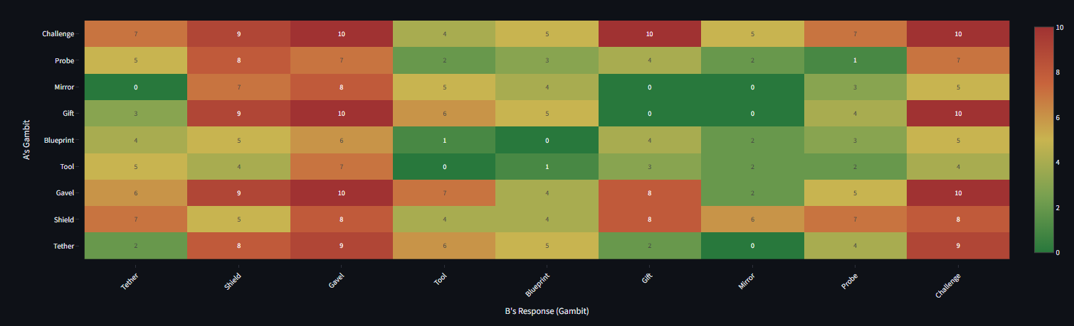

2. Predictive Logic (The "Most Likely" Chain)
Use these tables to predict the likely behavior of an actor based on their current psychological state.
Logic Summary
- Identify the underlying Need (e.g., Safety).
- Filter through the Worldview (e.g., likely Survival).
- Predict the Gambit (e.g., will likely lead to a Shield or Tether).
- Consult Friction Matrix to determine the outcome when met by an opponent's Gambit.

Step 1: Need → Worldview
Ordered by likelihood (highest to lowest)
Primary Need | Most Likely Worldviews
Safety | Survival, Deficiency, Operational
Autonomy | Identity, Operational, Ludenic
Competence | Operational, Identity, Unity
Significance | Identity, Deficiency, Sacred
Order | Operational, Survival, Unity
Belonging | Unity, Deficiency, Ludenic
Meaning | Sacred, Unity, Identity

Step 2: Worldview → Gambit
The "Tools" most commonly reached for within a specific lens.
Worldview | Most Likely Gambits
Survival | Tether, Shield, Probe
Deficiency | Tether, Gift, Shield
Identity | Gavel, Challenge, Probe, Shield
Operational | Tool, Blueprint, Probe
Unity | Mirror, Gift, Tether
Ludenic | Gift, Probe, Mirror
Sacred | Gift, Mirror, Tether

